Introduction

What is 1C:Enterprise?
1C:Enterprise is a universal cloud and on-premise system of programs for automating a company’s financial and wider operational activities. It is a suite of software tools employed by developers and users.
The system can be logically divided into two major components that are closely interrelated: an application and the platform on which the application runs.
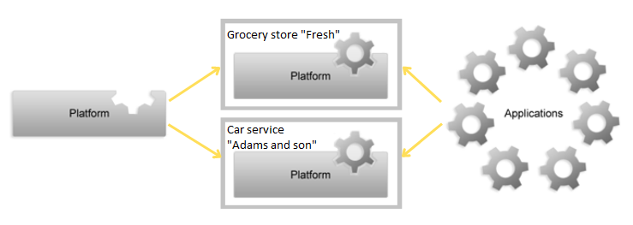
To explain the relationship between the system components of 1C:Enterprise, we compare it to a Blu-ray player. It is well known that a player is required for watching videos, listening to music, or playing other media content. The Blue-ray is standard but it meets the wide variety of customer needs through the range of discs out there with video or music to suit any taste.
To watch a video, you need to put a Blu-ray disc into a player, and the player will reproduce the content (video) that is recorded on it. In addition, Blu-ray players let you record your own content, i.e., create a new Blu-ray disc with a home video.
On its own, the player is useless without a Blu-ray disc, and likewise, a Blu-ray disc is useless without a player (except perhaps as a coaster for your coffee cup). Getting back to 1C:Enterprise, we can say that the platform is a type of "player", and an application is a "disc". The platform allows you to run the application, as well as modify it or create a new one. There is a single platform (1C:Enterprise 8), but an unlimited number of applications can be created. To run an application, you always need to have both the platform and the application itself (see the diagram above). The platform does not perform any automation tasks on its own, since its purpose is to provide the environment for developing and running applications. The same is also true for an application: it needs 1C:Enterprise Platform to run.
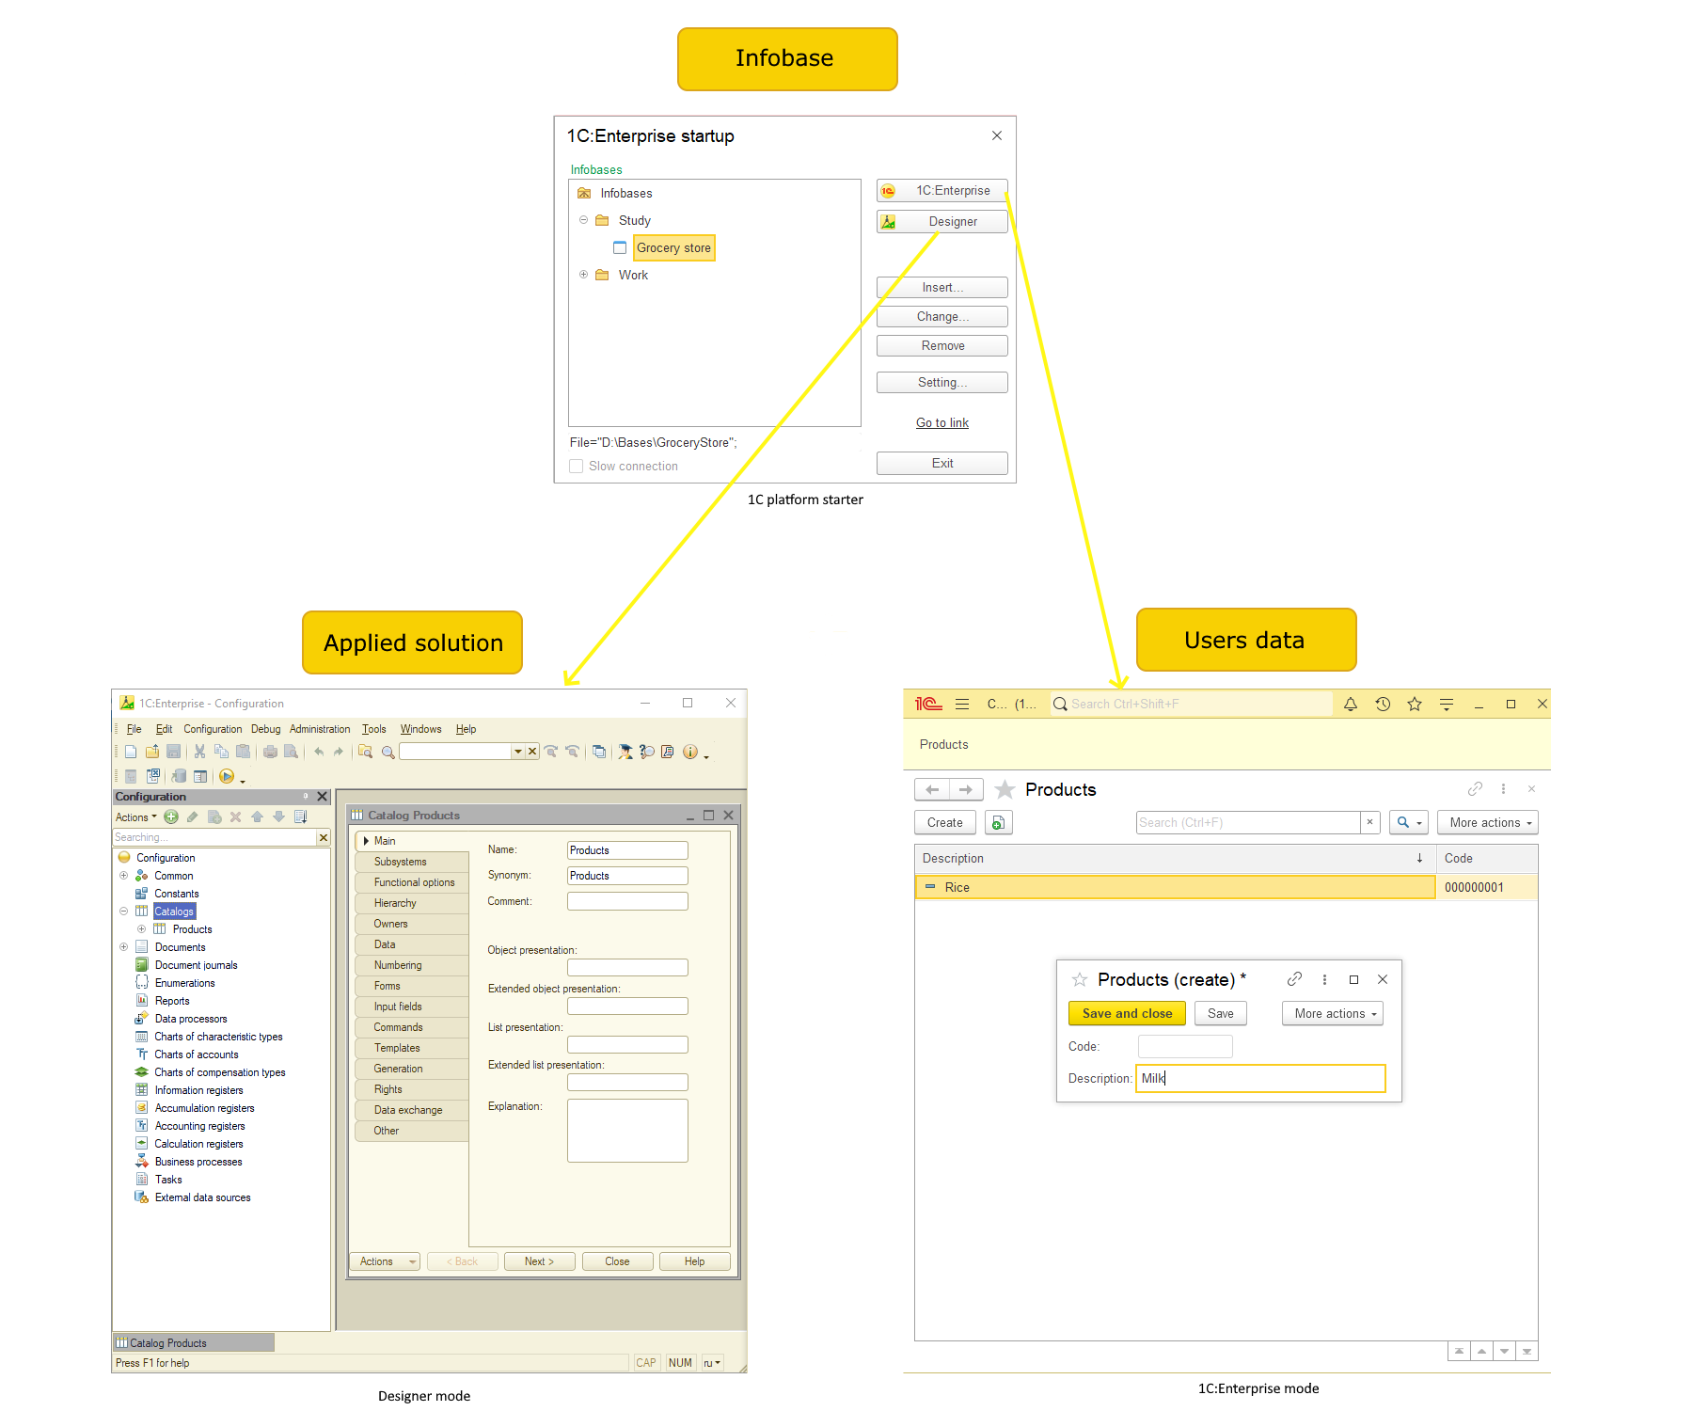

Advantages
1C:Enterprise platform offers the following advantages:
- Drastically reduces technological complexity, ergonomics, and performance issues of enterprise software systems.
- Allows power users to implement specific business processes.
- Speeds up and standardizes business application development, customization, and support.
- Provides complete openness of UI and solution code, which allows better understanding and modification of business processes.
- Is ready for integration with existing 1C applications and third-party systems.
- Supports web-services, ODBC, COM, and so on.
- Supports your preferred architecture: Windows/Linux, MS SQL, PostgreSQL, IBM DB2, and Oracle DB.
- Includes on-premise or managed hosting web-based delivery, as well as Web, tablet, or Windows client.

Platform architecture
The primary purpose of the platform is increasing the level of abstraction for applied solution development and usage scenarios. This advances you from low-level technical concepts to more substantial high-level ones, which are widely used by experts and end users in the subject area. This significantly speeds up and unifies the development and support of applied solutions.
At the same time, the platform solves typical tasks related to performance, ergonomics, functionality, and more.

Platform and applied solutions
1C:Enterprise system is explicitly divided into the platform and applied solution parts. The platform serves as a framework for running applied solutions:
- The platform is a basis for building applied solutions.
- The platform provides an execution environment for applied solutions.
- The platform provides tools for development, administration, and support of applied solutions.
In addition to that, an applied solution is an independent entity that can be delivered as a standalone software product. Still, it fully relies on platform technology.

Low-code approach
The platform uses a low-code approach, where the development is largely driven by visual modeling and the use of embedded mechanisms and code programming is used only in some specific or unique situations.
Low-code approach implies a high level of abstraction from technology that allows developers to focus on applications’ business logic. Developers create applications using high-level components and templates as building blocks. This way low-code approach speeds up the development process, making it more responsive to changing requirements and customer feedback. Besides, some low-code platforms allow creating web, desktop, and mobile versions within a single cross-platform development environment. A single, all-purpose IDE and a high level of abstraction make a barrier to entry into low-code technology much lower as compared to pro-code.

Metadata as a method of describing applied solutions
An applied solution is not literally written in a programming language. A programming language is only used when necessary.
The basis of an applied solution is its metadata. It forms a structured declarative description of an applied solution. Metadata provides the object hierarchy for building all the major parts of an applied system, which defines all aspects of its behavior. When an applied solution is running, the platform actually "plays" (interprets) metadata, which provides access to applied solution functionality.
Metadata describes data structures, type content, object relations, their behavior and visual presentations, access restriction system, user interface, and so on. Metadata defines not only what is stored in the database but also the purpose of stored data, its role in the system, and relations between data arrays.
The programming language is only used for solving tasks that do require algorithmic descriptions, such as tax calculations or verification of entered data.

Building applied solutions based on a model
The platform is oriented on building applied solutions on the basis of a specific model. This model describes the entire philosophy of applied solution development: data structure building methods, data relation types, data manipulation techniques, business logic description methodology, relations between data and interface objects, dividing functionality between system levels, and more.
It is important that all applied solutions follow that model, which ensures their uniformity and predictable behavior.

Standard applied object prototypes
1C:Enterprise development model assumes that the entire applied solution is described by its metadata as a set of applied objects based on a certain number of prototypes (classes). Each prototype describes a set of applied solution objects or processes that have similar behavior and similar roles in the applied solution concept. Examples of prototypes are catalogs, documents, and accumulation registers.
Each prototype has a basic implementation that defines the functionality of objects based on the prototype: structure of stored data with some predefined fields, types used in the programming language, methods, events, properties, typical operations, typical viewing and editing options, access restrictions, and so on.
So, an applied solution is essentially comprised of objects, each object group having a specific role in the applied solution. This approach significantly strengthens the methodology of describing the system in terms of metadata and the model-based building of applied solutions

Multitier architecture
Applied solutions based on the platform utilize a 3-tier architecture that includes:
- Client application
- 1C:Enterprise server cluster
- Database server (as a database server can be used: Microsoft SQL Server, PostgreSQL, IBM DB2, Oracle Database).
The user's program (client application) interacts with the 1C:Enterprise server cluster, and the cluster, if necessary, accesses the database server.
Physically, the 1C:Enterprise server cluster and the database server can be located on the same computer or on different ones. This allows the administrator to distribute the load between servers if necessary.
Using a 1C:Enterprise server cluster allows to concentrate on it the most extensive data processing operations. For example, when executing even very complex queries, the program running at the user will receive only the selection it needs, and all intermediate processing will be performed on the server. It is usually much easier to increase the capacity of a server cluster than to upgrade the entire fleet of client machines.
Another important aspect of using a 3-tier architecture is ease of administration and streamlining user access to the infobase. In this option, the user does not need to be aware of the physical location of the configuration or database. All access is provided through a cluster of 1C:Enterprise servers. When accessing an infobase, the user must specify only the cluster name and infobase name, and the system prompts for the user's name and password, respectively.
On one hand, this provides a wide range of scaling options, from personal use to automation of large, geographically dispersed enterprises.
On the other hand, multi-tier architecture provides a choice between several DBMS (database management system) for storing applied data.
Major system components can run on both Windows and Linux operating systems. Besides that, 1C:Enterprise web client can run on Mac OS X and Apple iOS computers.
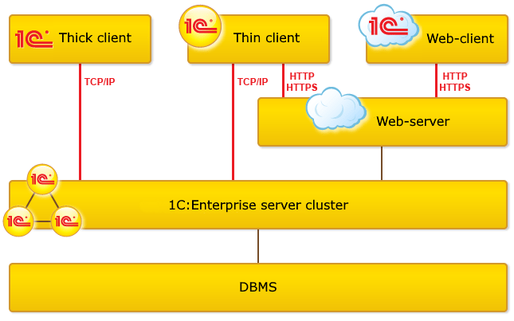

Web client and thin client
Users can choose between two client applications: thin client and web client. Both of them have specific advantages.
Thin client provides broader functionality because it runs on a user workstation. For example, it has access to the client computer file system and can use local licenses installed on the user computer.
Web client is more universal because it does not require installation. Instead of a computer operation system environment, it is executed in a browser environment. Once a user runs a browser and enters the address of the Infobase web server, the web client is delivered to their computer and started. The web client allows running applied solutions on computers that are not prepared (or even cannot be prepared) for this in advance.
It is important that applied solution development is not affected by the user's choice of the client. The web client compiles client modules developed in a configuration and executes them on the client side.

Cross-platform design

Client applications on various platforms
Users can work with 1C:Enterprise infobases from various devices with various operating systems using any of the available client applications. The thick and thin client are available on Windows and Linux. The web client is a browser application compatible with all popular Internet browsers.
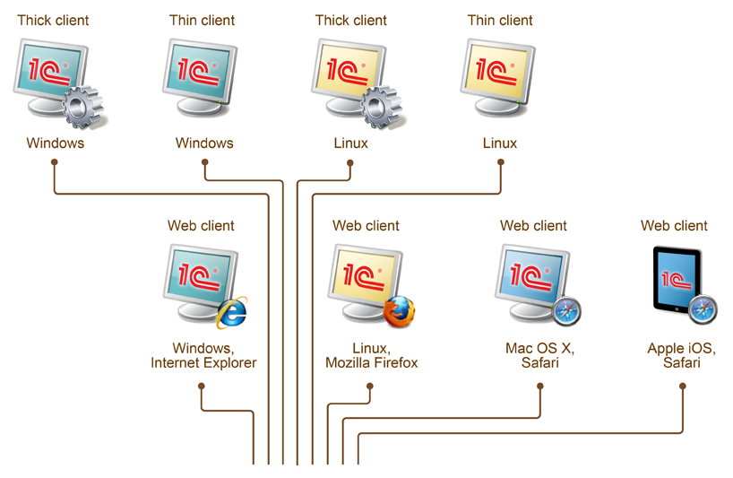
For example, Windows users can choose from:
- thick client;
- thin client;
- web client with Windows Internet Explorer or Google Chrome browser.
Linux users can choose from:
- thick client;
- thin client;
- web client with Mozilla Firefox.
Mac users can connect to 1C:Enterprise using the web client with the Safari browser.
For Apple mobile devices, the web client was tweaked for better usability on small displays and touch input support. You can, therefore, use a fully functional 1C:Enterprise client on such mobile devices as iPad, with the mobile Safari browser.

Cross-platform system
Using the web client allows you to run all the core platform components on a single operating system such as Linux.
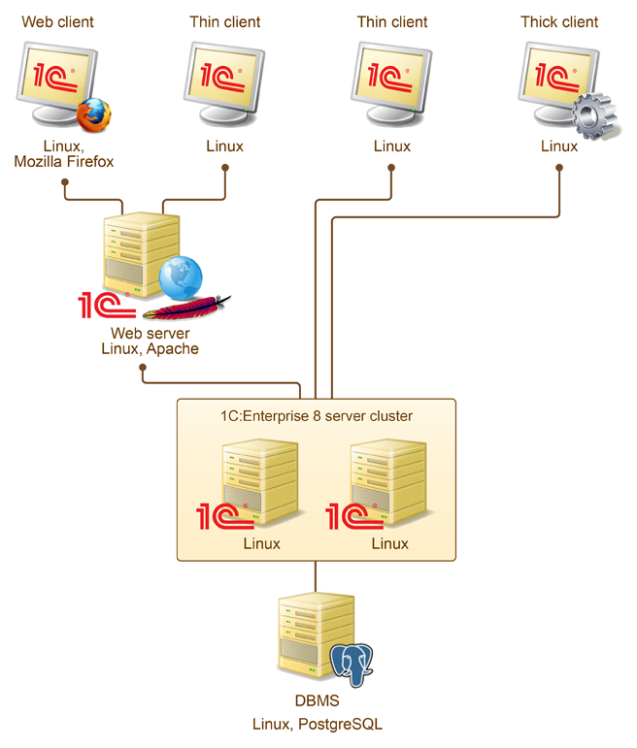

Another option is to run all the platform components on Windows.
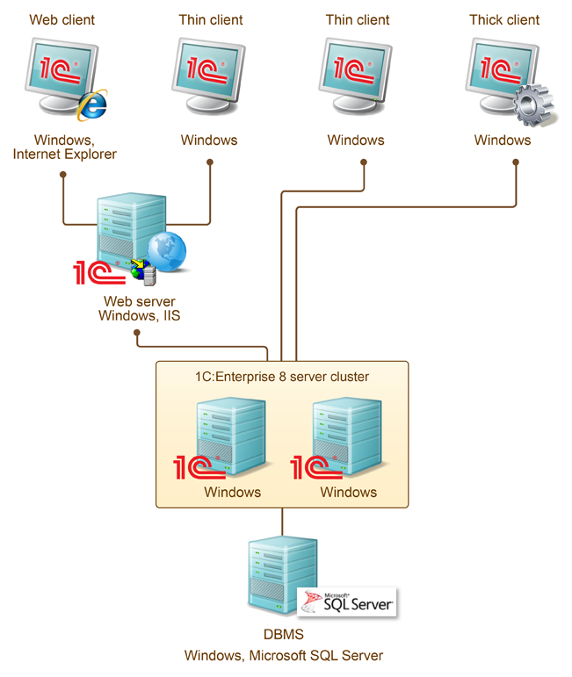
1C:Enterprise architecture allows you to mix any components running on different operating systems in a single 1C:Enterprise system.
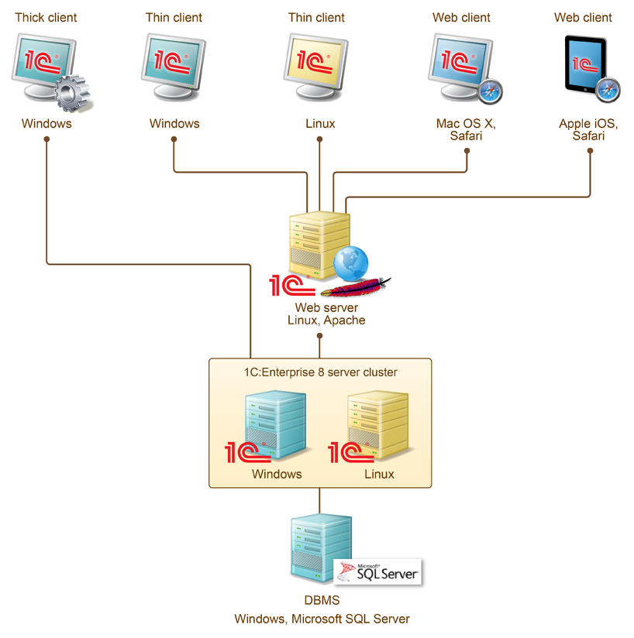

Cross-platform cluster
Computers that form a cluster can run Windows or Linux operating systems. A cluster can include working servers running on different operating systems.
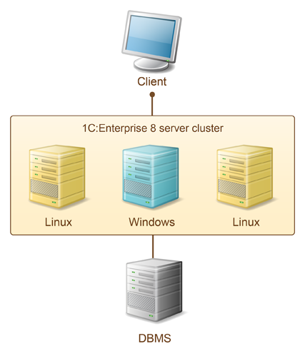
Working servers that run on Linux have the following limitations:
- Microsoft SQL Server DBMS is not supported;
- interaction with COM objects is not supported;
- authentication on the server is performed using Kerberos protocol;
- connection with the Internet is not supported.

Cloud technology
1C:Enterprise applied solutions can run as cloud services.

The data separation platform feature serves as a basis for its cloud technology. Due to data separation, applied solutions can run in multitenant architecture where a single object instance running on a server is used by many customers or organizations.
A scalable fault-tolerant server cluster provides services for a large number of simultaneous customer connections. Customers access a cloud infobase over HTTP or HTTPS, which ensures service availability from any location in the world.
Finally, 1C:Enterprise cloud service infrastructure supports SaaS application delivery model. This business model implies that a vendor develops and manages an applied solution while providing access to customers over the Internet. This approach eliminates the need to install, update, and support software and hardware on the customer side. Customers only pay for the service.

Start of working with infobase

Creating new infobase
After installing 1C:Enterprise platform, let's start creating the infobase.
- Open “1C starter”
- Click Insert
- Select “Creating new infobase”
- Select “Create an infobase without a configuration to develop a new configuration or restore a previously dumped infobase”
- Specify infobase name (how it would appear at list) and select the inbobase location type. “On the given computer or on the computer in the local network” means the infobase would store in a special file format (.1CD extension), so no need to have 1C:Enterprise server and Database Management Server.
- Specify infobase directory and choose Language for location settings (like date format). For example, if you select English (United States), the date format will be mm/dd/yyyy and the time format will be 12 hours (AM/PM)
- Click “Finish” without making changes at the last window.
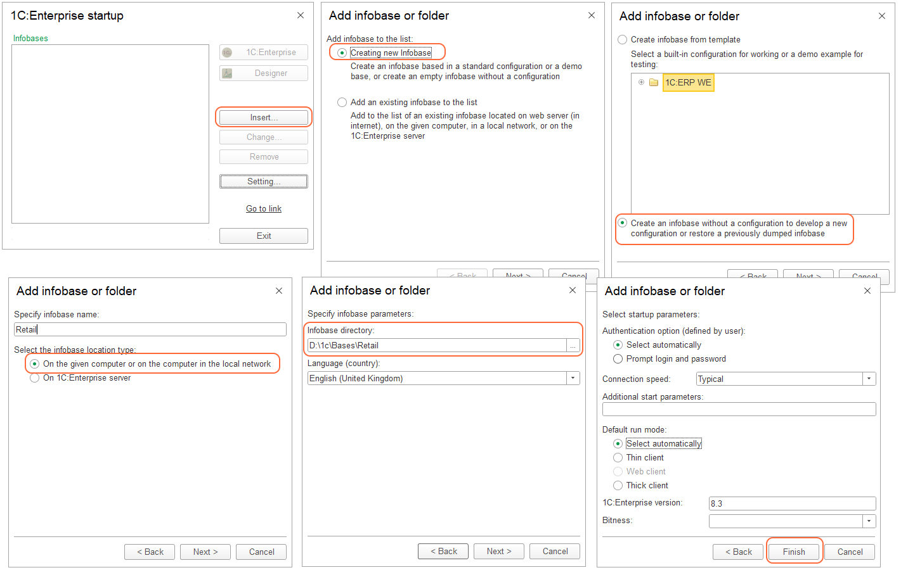

As a result a new infobase appears at list:
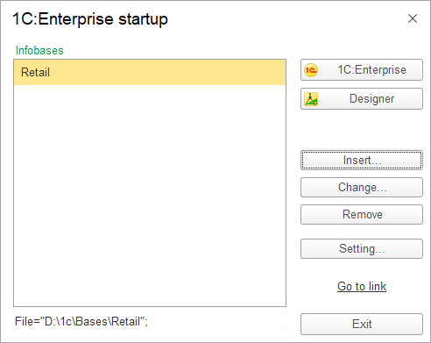

Removing infobase from a list
- Select an infobase at the list
- Click “Remove” button
- Click “Yes” at opened window
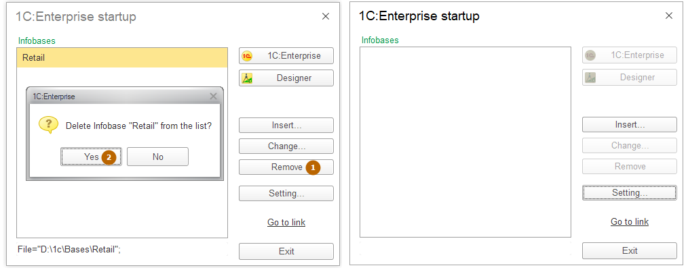
Note: removing an infobase from the list doesn’t remove it from disk or DBMS. You should do it directly if needed.

Adding an existing infobase to the list
- Click “Insert” at the 1C:Enterprise infobases list
- Choose “Add an existing infobase to the list”
- Specify infobase name
- Select the infobase location type and path to it (directory for file type, address for web-server type or server clusters and infobase name for client-server type)
- Click “Finish”
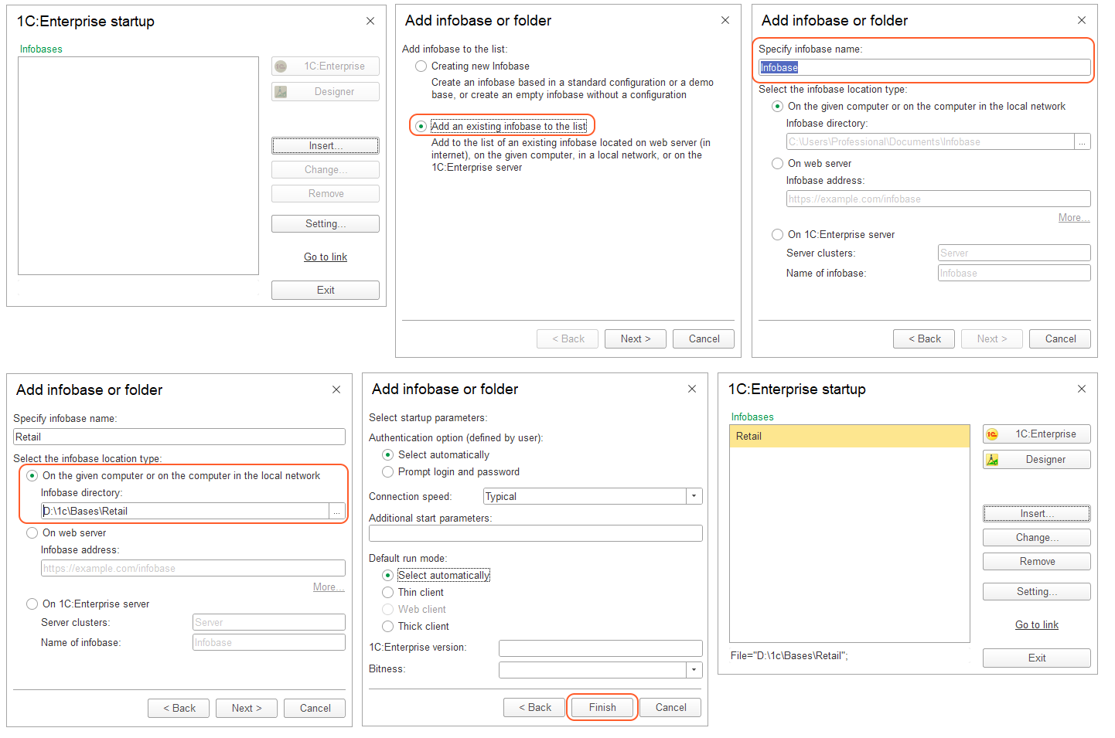

Dumping an infobase to a file
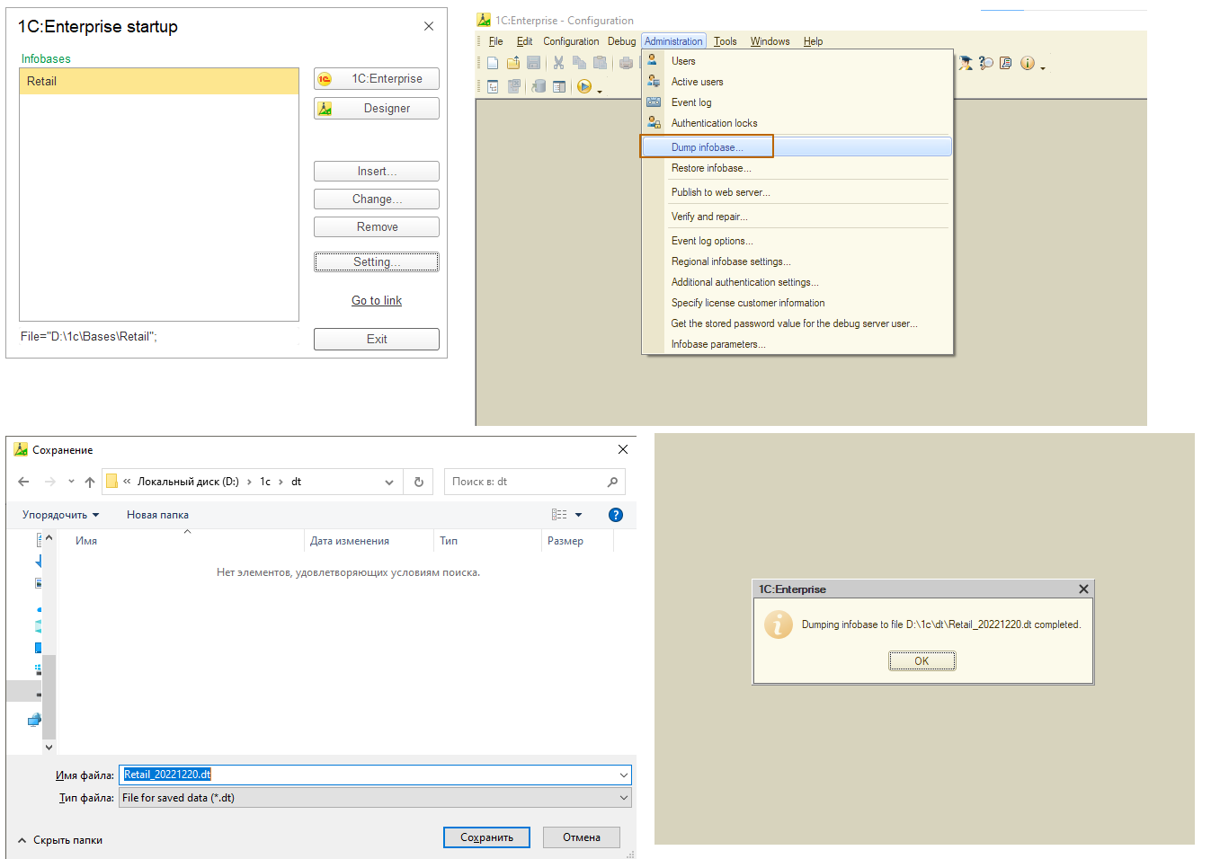
- Open an infobase in designer
- Go to “Tools” and click “Dump infobase”
- Specify a directory and a name of the file
- Wait for the completion message (click “Ok”)

Restoring an infobase from a file
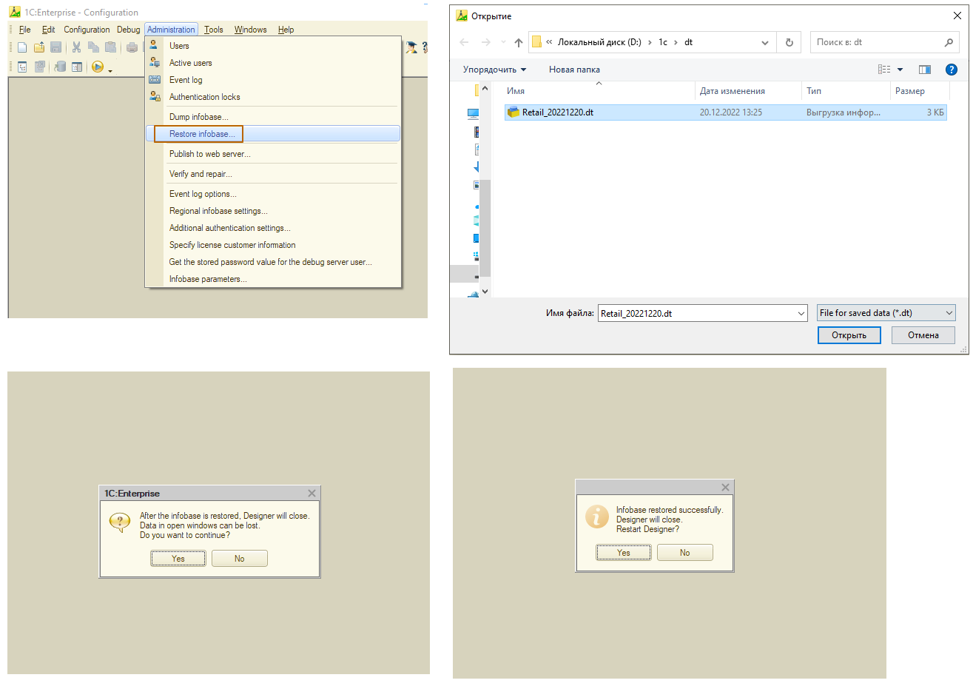
- Open an infobase in designer
- Go to “Tools” and click “Restore infobase”
- Choose a file with saved data
- Agree with continuing at opened window
- Wait for the completion message. Click “Yes” to restart designer or “No” to close it without restart

Start of working with configuration (applied solution)

Opening configuration
To start working with infobase’s configuration for the first time we need to open it at designer
- Open designer
- Go to “Configuration” – “Open configuration”
- Wait for the completion of opening. The result will be a window with a configuration “tree”
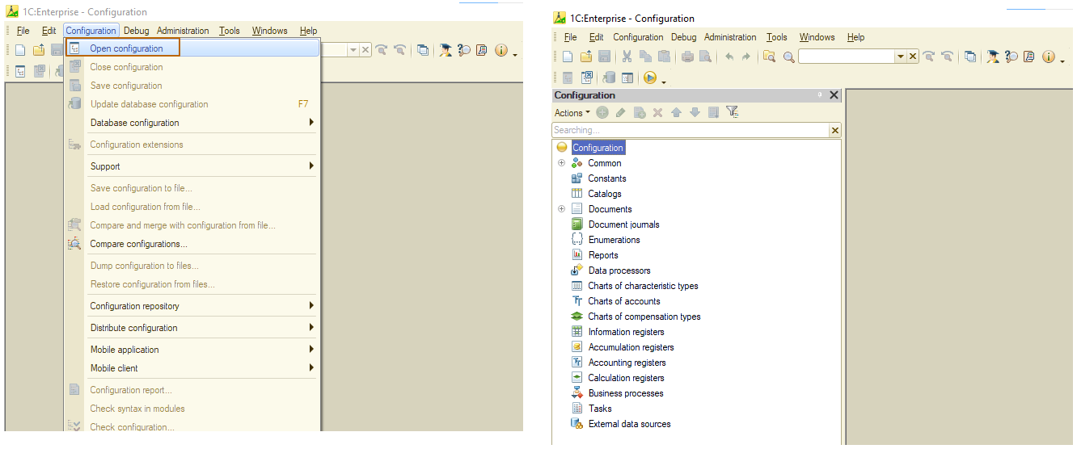

Saving configuration to a file
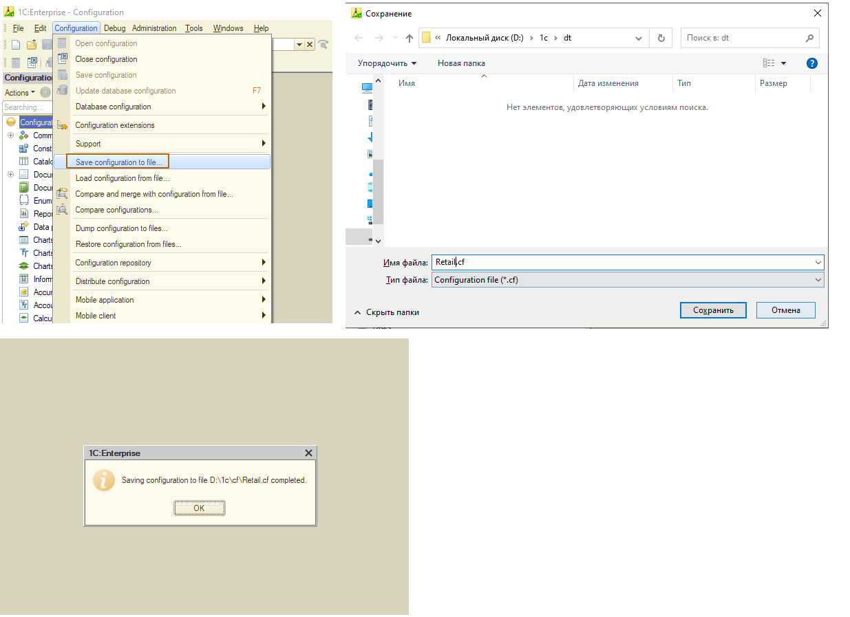
- Open designer
- Go to “Configuration” – “Save configuration to file”
- Specify a directory and a name of the file
- Wait for the completion of operation.

Loading configuration from a file
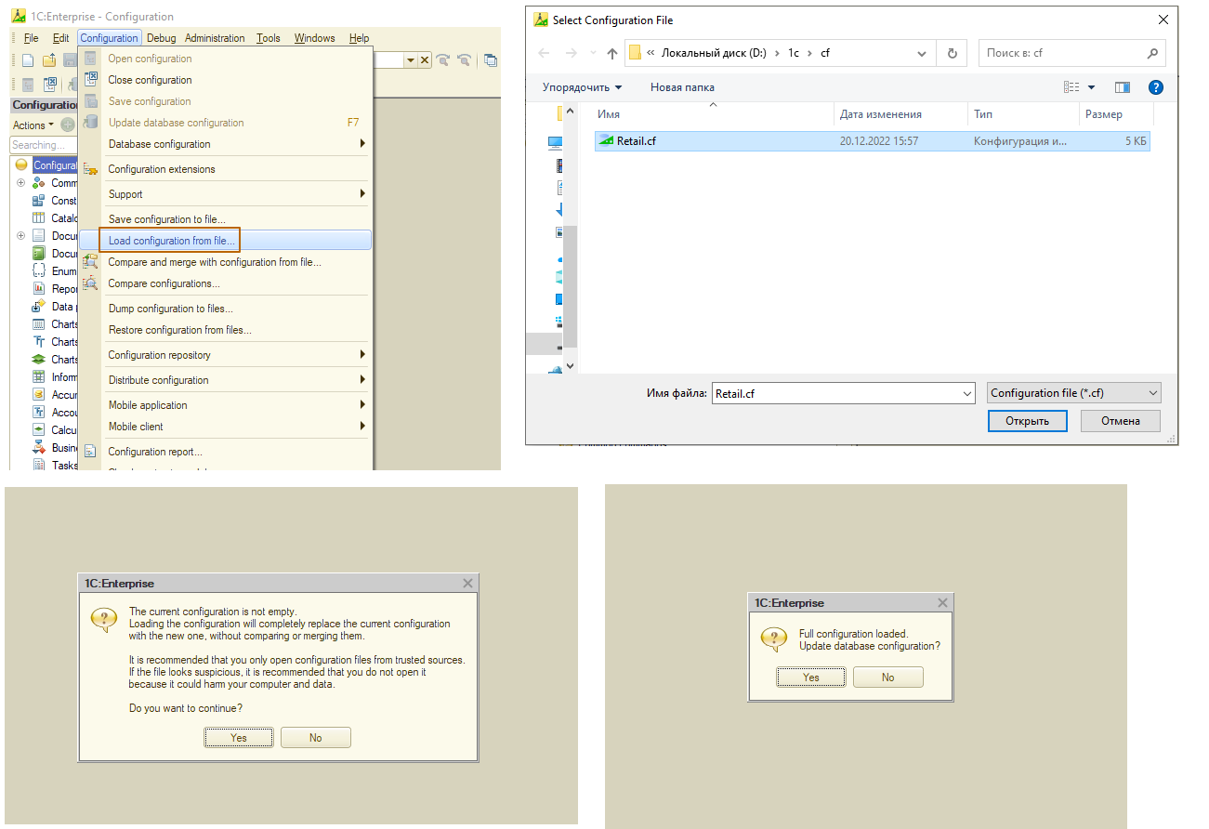
- Open designer
- Go to “Configuration” – “Load configuration from file”
- Choose a file with configuration
- If configuration of an infobase is not empty, there will be a warning message, click “Yes” to agree with replacement of configuration
- At opened windows click “Yes” to update an infobase configuration or “No” to not update it.

